## C:\Users\Abubakir\AppData\Local\Microsoft\Windows\INetCache\Content.Word\Global Health Care.png

## 

## Group Members:

## Abubakir Myrzaly – 300931945

## Syed Nasir Gohary – 300937424

Table of Contents

Project Title: 1

Group Members: 1

Abubakir Myrzaly – 300931945 1

Syed Nasir Gohary – 300937424 1

Detailed description 3

Version History 3

Typography and Color 3

Wireframes 3

Capture Section 3

# Detailed description

“Global Health Care” is a clinic in the downtown of Toronto city. “Global Health Care” is a very popular clinic due to its excellent customer service, great number of fully-qualified therapists and location. Thousands of customers attend clinic every day to get treatment, professional advice and medical support. As a result, the management of “Global Health Care” clinic wants to establish a responsive web application through which patients will be able to access clinic’s services.

The customer is going to have personal account and will have access to book an appointment with our specialists. We will provide a patient with a list of most common symptoms and based on patient’s choice we will assume what kind of disease he has. Then, we will provide him with many employees available from the department responsible for that disease or illness. Patients will able to contact our 24/7 servise, that can help to book an appointment or talk about what kind of disease they have.

# Version History

V0.1 Created project and main page

V0.2 Created database and connected to it

V0.3 Finish designing main page

V0.4 Create Register page

V0.5 Create Log in page

V0.6 Create Appointment page

V0.6 Create Contact page

V0.7 Finish with functionality of the web

V0.8 Finish with basic security

V0.9 Finish CSS for the web site

V1.0 Full featured web site

# Github Screencapture

GitHub Repo: https://github.com/sgohari/Comp229-TeamAssign/commits/master

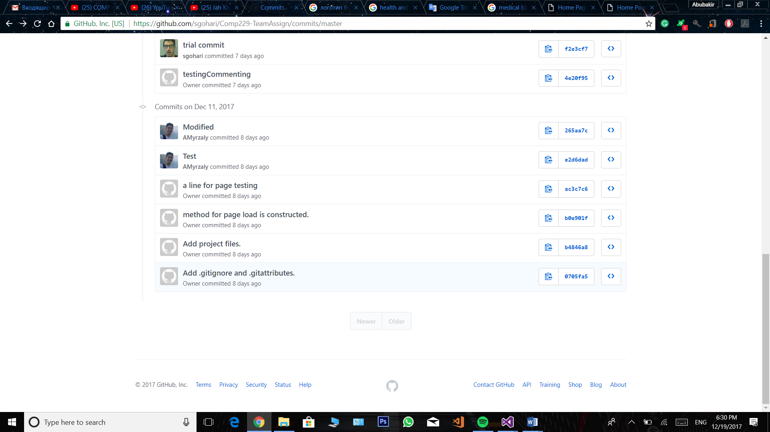

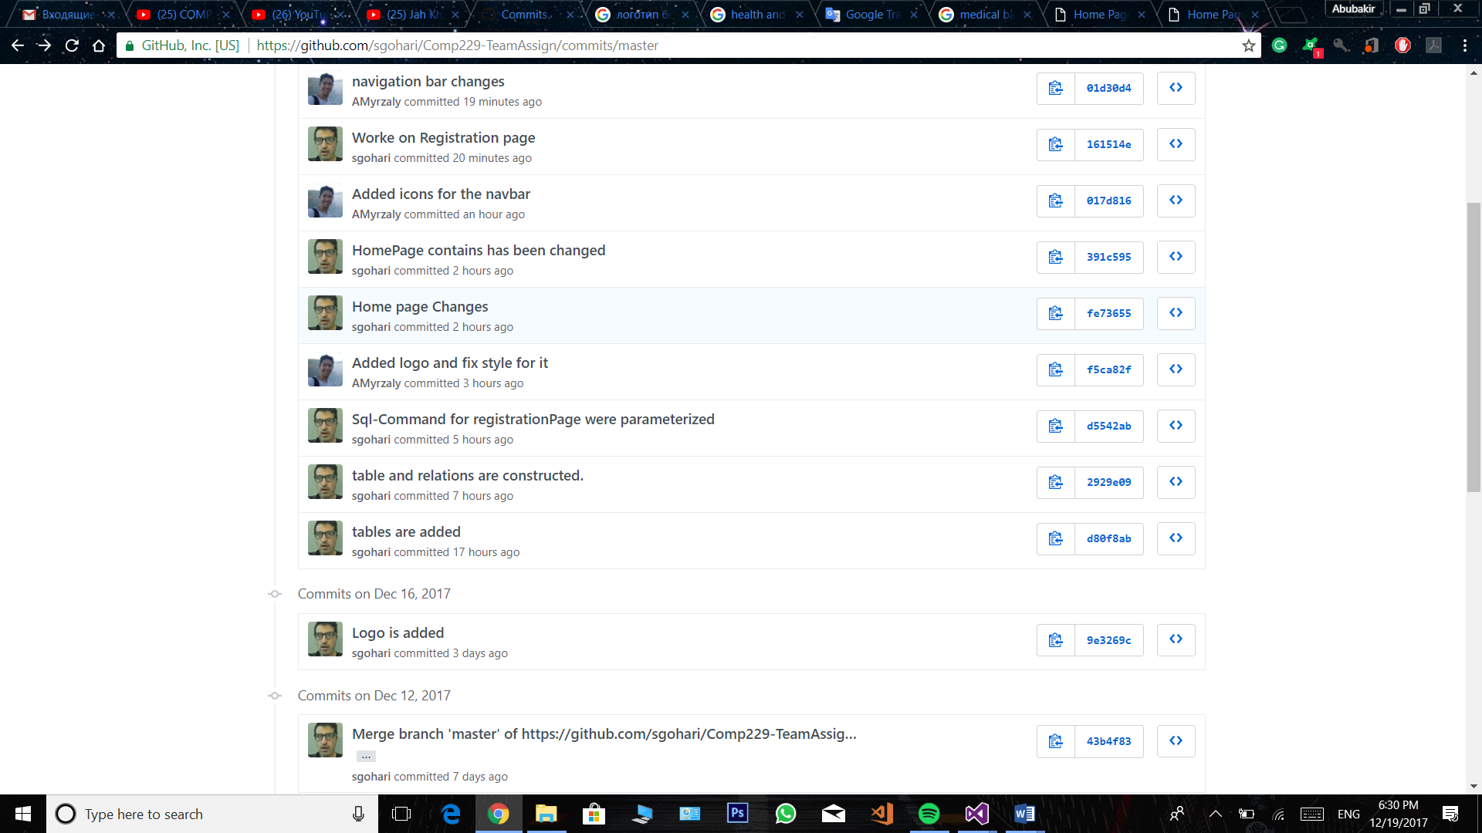

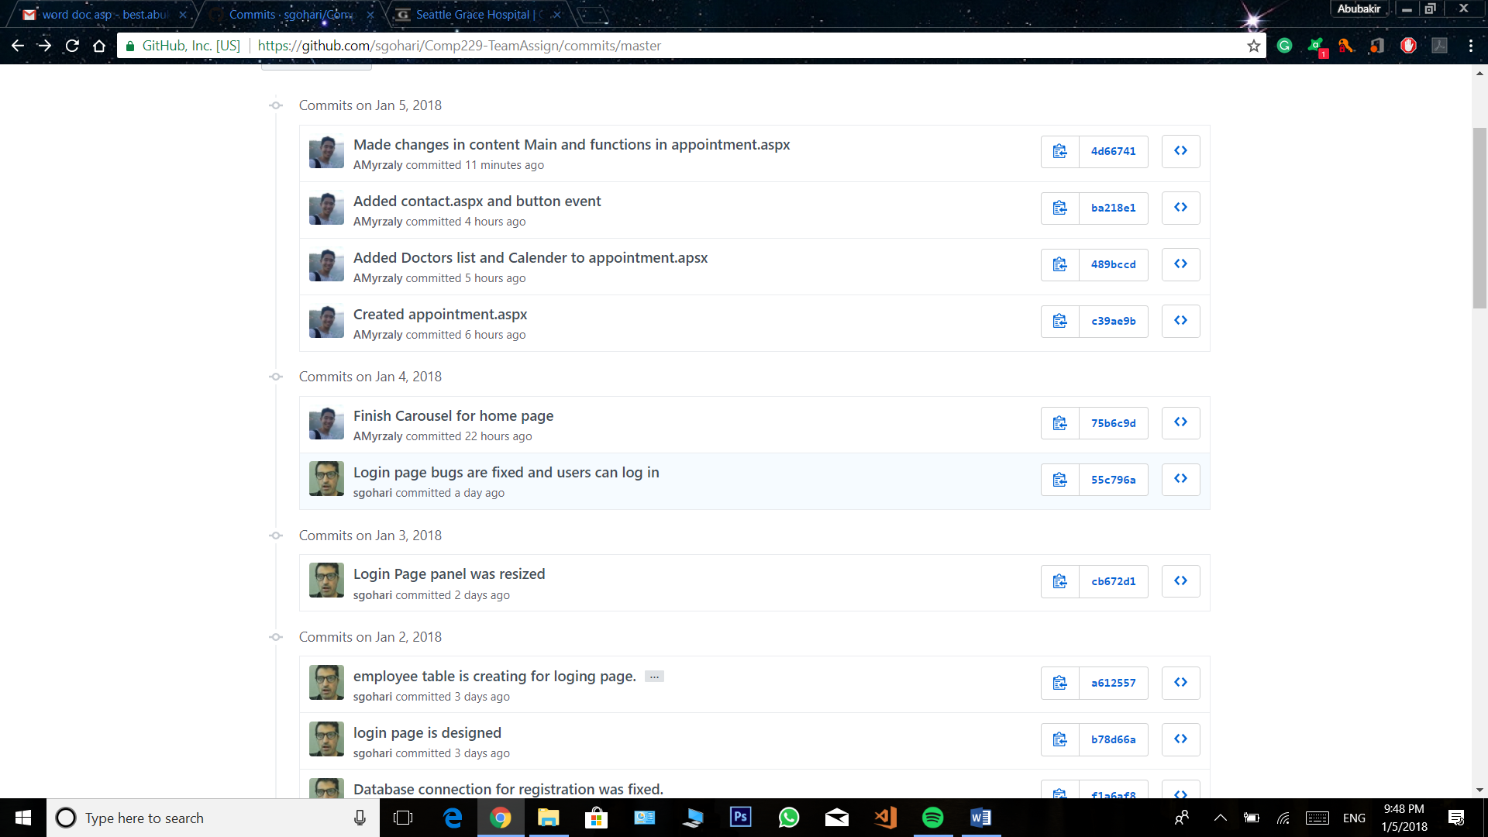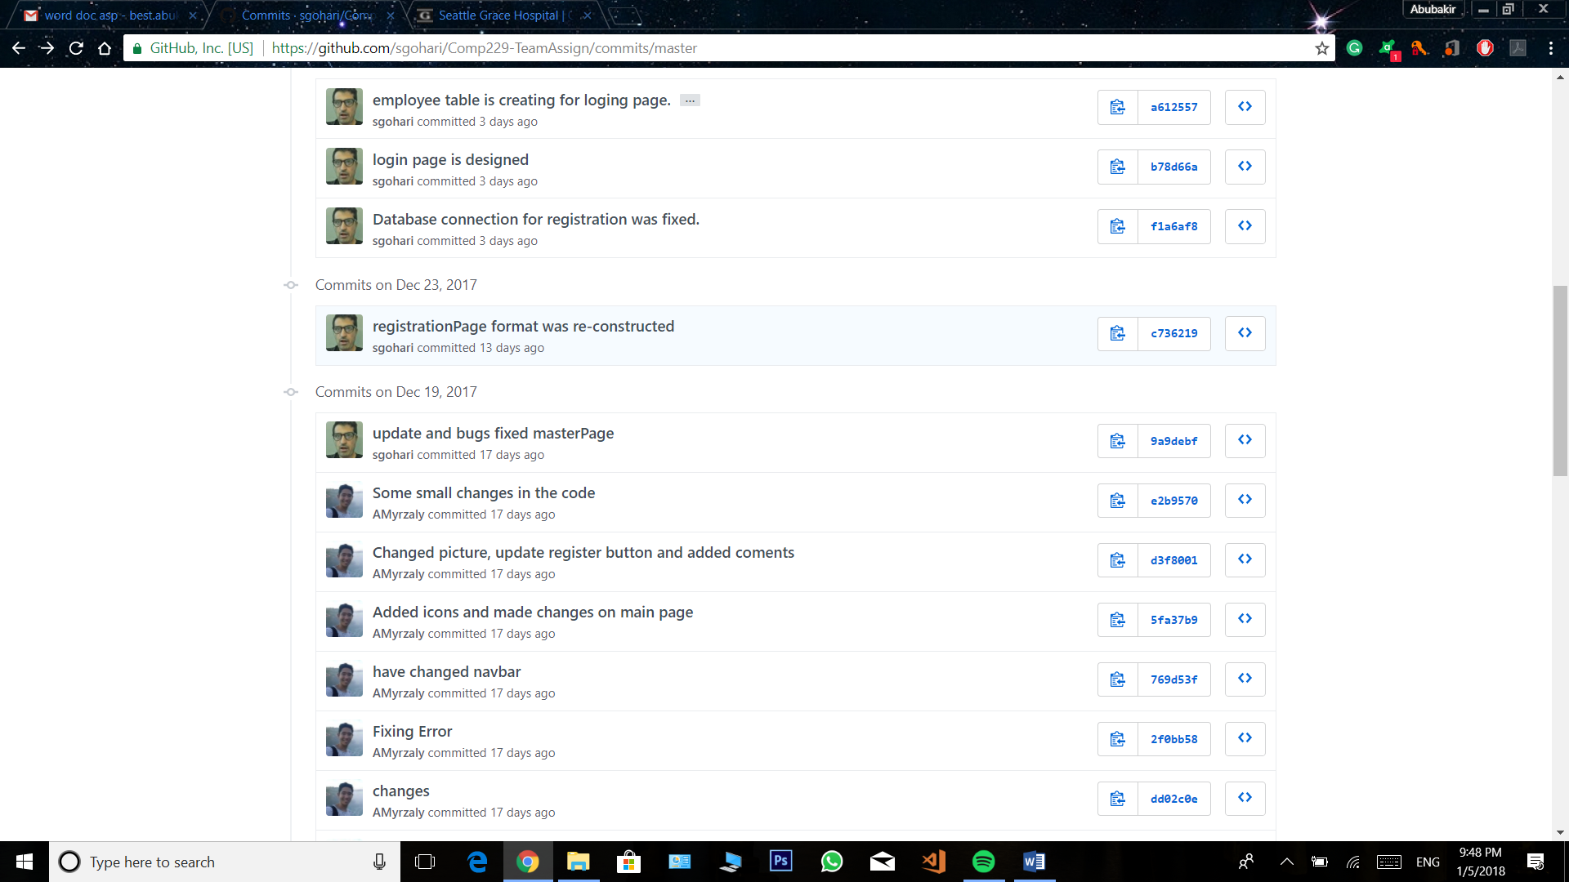

# Typography and Color

All fonts are client defaults to make our web site more flexible and clean.

Lucida Sans

|  |  |  |  |
| --- | --- | --- | --- |
| Name | RGB | HEX value | Snippet |
| White | rgb(255, 255, 255) | #ffffff | |  | | --- | |  | |
| Grey | rgb(214, 215, 223) | #D6D7DF | |  | | --- | |  | |
| Dark-Blue | rgb(66, 139, 202) | #428BCA |  |
| Green | rgb(92, 184, 92) | #5CB85C |  |
| Dark-Grey | rgb(128, 128, 128) | #808080 |  |

# Wireframes

Main page:

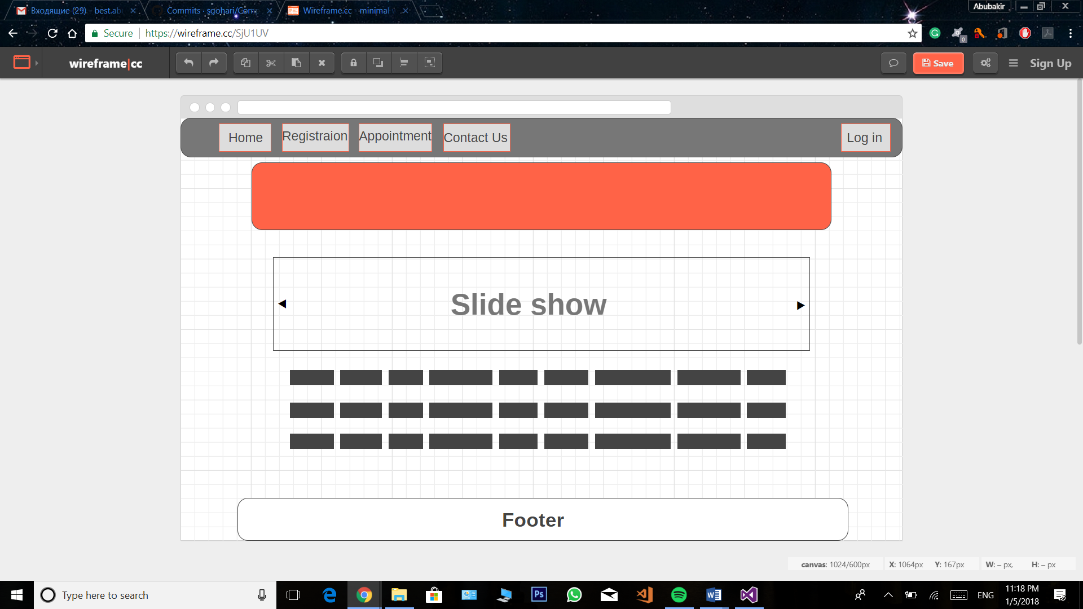

Register page:

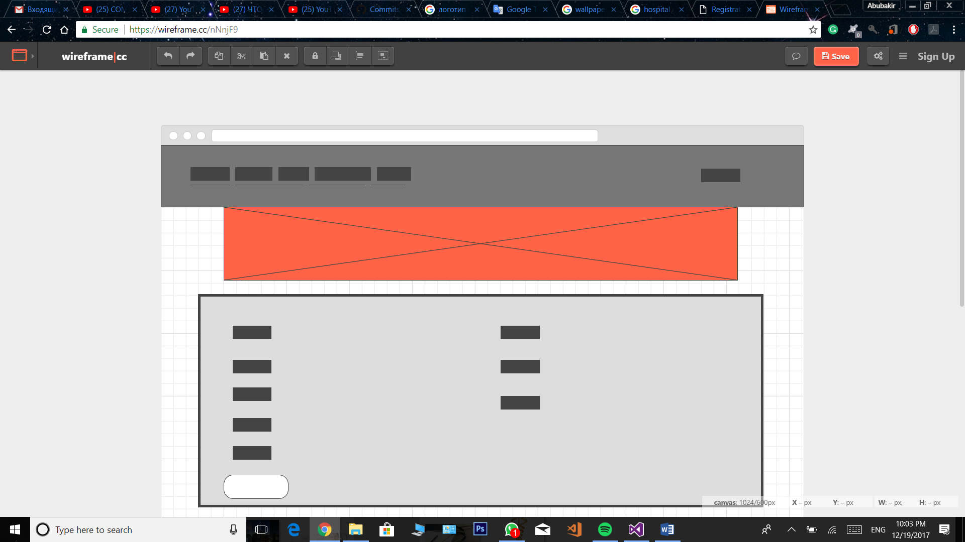

Login Page:

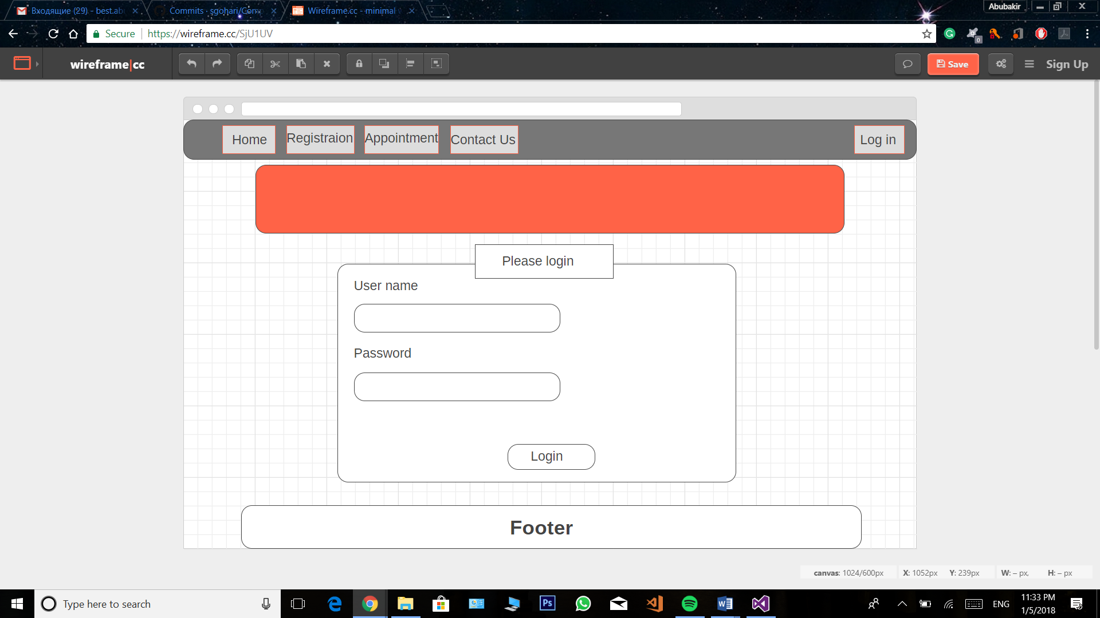

Contact us:

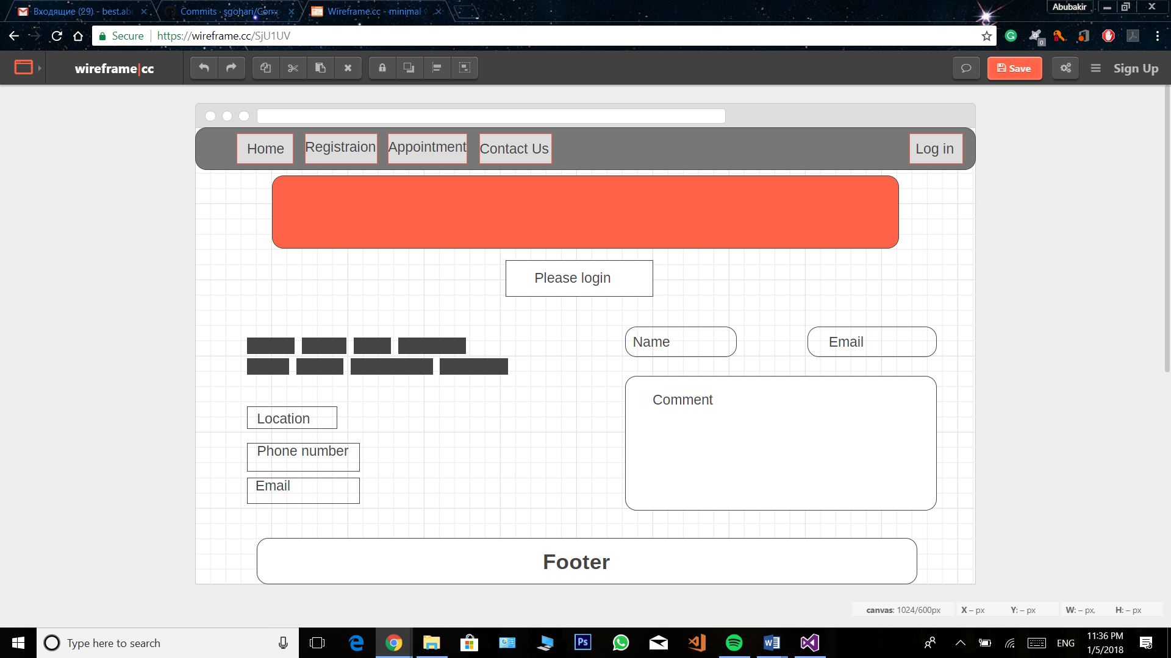

# Capture Section

Main page:

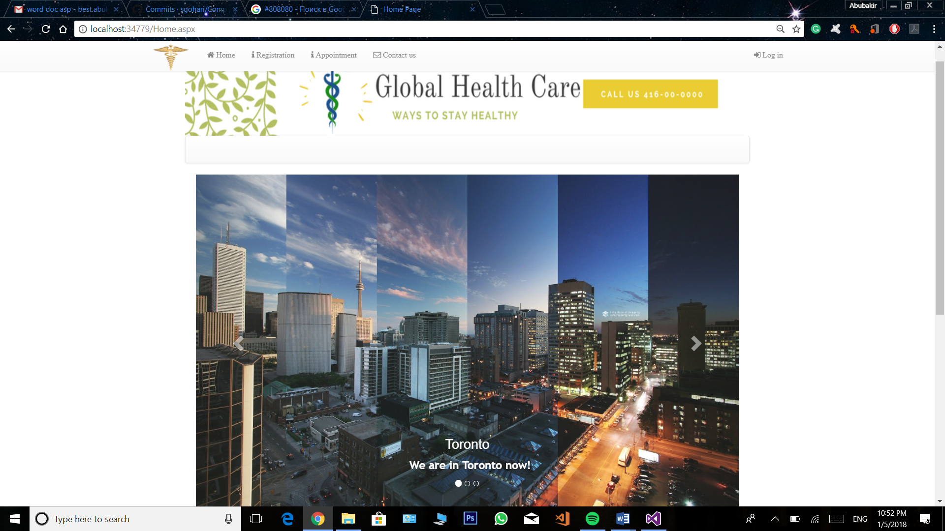

Register page:

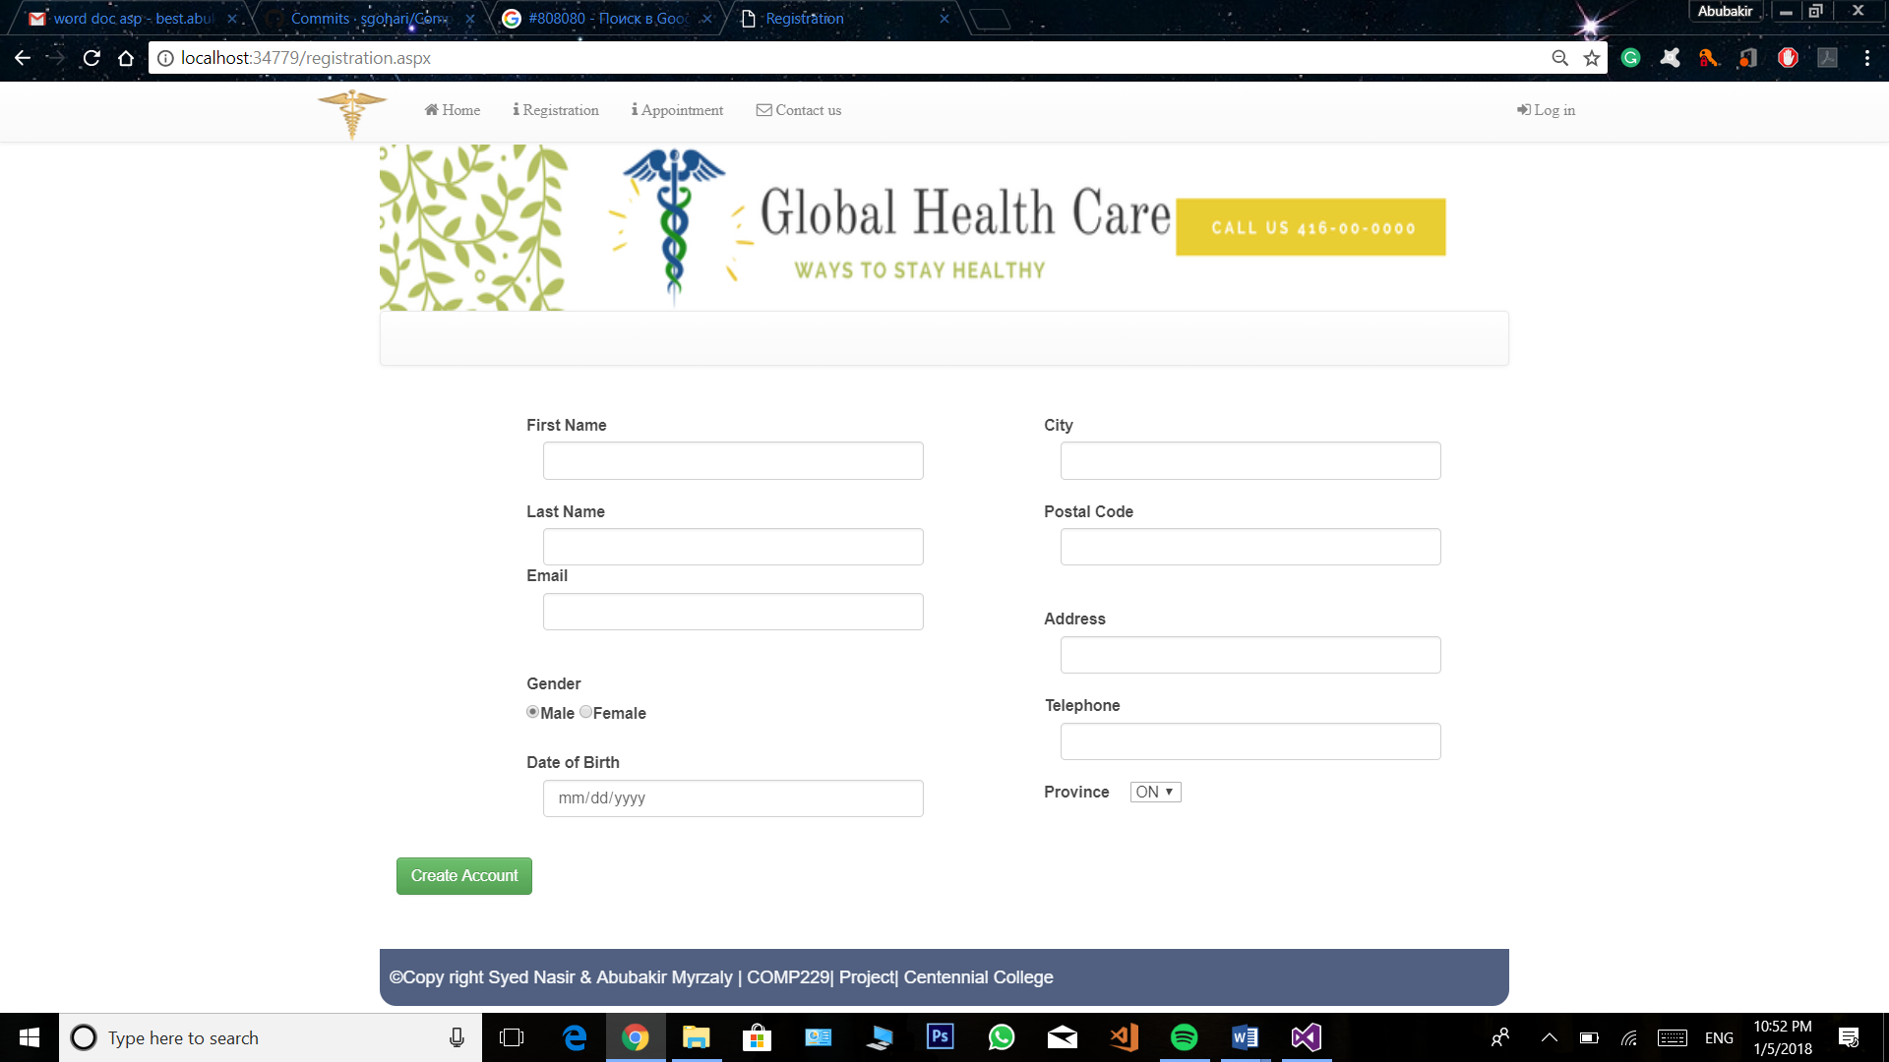

Contact us:

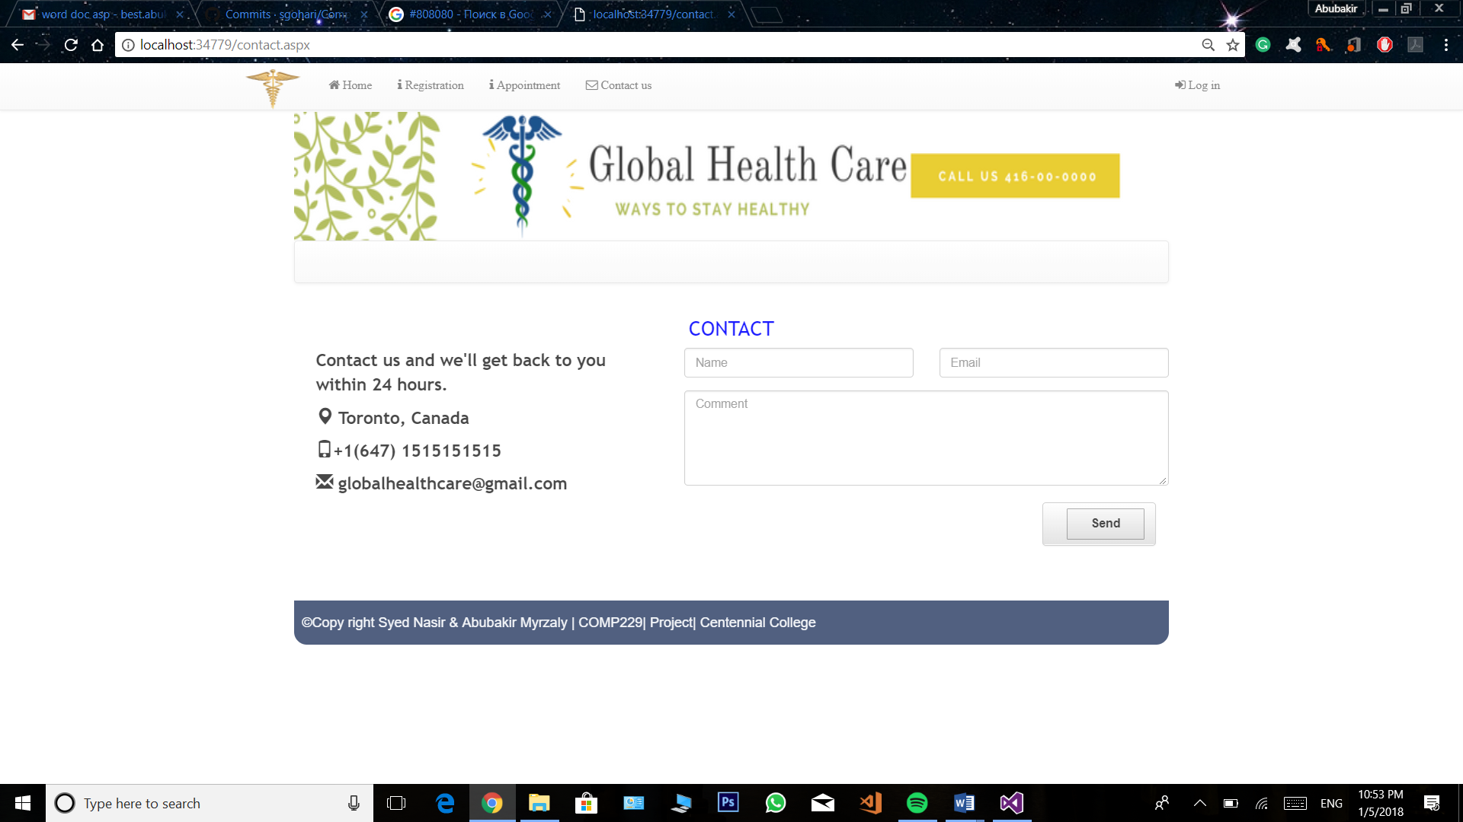

Log in:

